August 5, 2019

Biotechnology Regulatory Services
Animal Plant Health Inspection Service
United States Department of Agriculture
4700 River Road Unit 146
Riverdale, MD 20737‐1236

RE: The Illinois Corn Growers Association comments on the Proposed Rule regarding Movement of Certain Genetically Engineered Organisms. Docket No. APHIS-2018-0034-0037

Dear Sir/Madam:

Illinois Corn Growers Association (ICGA) appreciates the opportunity to provide comments on the proposed update to 7 CFR 340. We represent more than 4,000 corn farmer members throughout Illinois who all rely on the latest and most up-to-date technology to sustainably manage the roughly 27 million acres of farmland, covering about 75% of our state. These farmers need every available tool to manage insect and weed infestations and grow enough grain to feed and fuel our world.

ICGA appreciates USDA’s recognition of the safety record of GE organisms and its efforts to streamline the oversight and regulatory framework for these products. A simplified pathway to bring new innovations to market will benefit farmers as they seek to control insect and weed pressures on their farms.

Overall, we support and trust USDA’s scientifically based regulatory system, and appreciate the agency’s commitment to continuing to use such an approach. We believe this system leads the world in fair and comprehensive reviews that enable new and innovative products to safely come to the market.

There are a few suggestions we would make to improve the proposed rule. These edits are detailed in comments submitted by the National Corn Growers Association and we would lend our support to their letter dated August 5, 2019.

Thank you for the opportunity to weigh in on this very important issue to Illinois farmers.

Sincerely,

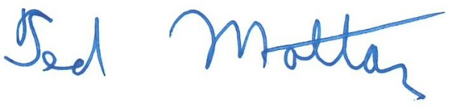
Ted Mottaz, President
1k3-9bfs-cfh8

