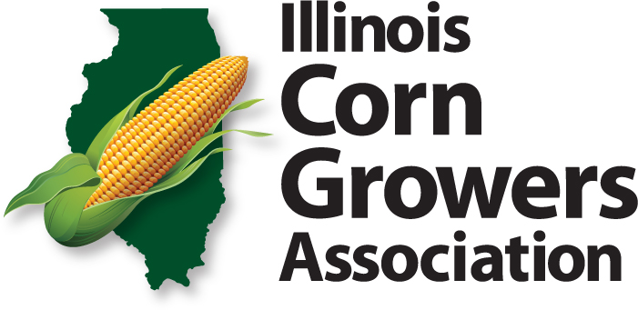

STATE POLICY RESOLUTIONS

November 19, 2018

Tax Policy

- Oppose the sales tax on all farm machinery and production inputs as a new way of raising state revenue. (11/13)

- State Programs should be controlled by a combination of budget cuts, program/benefit reductions and program eliminations. (11/10)

- BOARD POLICY-THAT we support sales tax exemptions on seed inputs for conservation practices. (11/13)

- BOARD POLICY - THAT we support policy prohibiting local government from passing stricter laws on agriculture than the laws of the state. (11/13)

- Oppose any increase in the state income tax and any attempt to move to a graduated state income tax. (11/13)

- Illinois estate tax exemption be a minimum of $5,000,000 and indexed for inflation. (11/13)

- Support changes in the IL tax structure that promote business growth, job creation and do not overly burden any one segment of the Illinois economy. (11/14)

Research & Education

- THAT the University of Illinois Extension again emphasize agriculture in programs and staff, especially at the educator level and in funding. (11/03)

Property Rights

- Resolved that the Illinois noxious weed law be enforced, including on all state owned roads, right of ways and other holdings. (11/04)

- Seek Illinois legislative action to protect farmers and land owners from liability suits resulting from recreational use of their property. (11/04)

- Work to promote legislation and rule changes that would reduce the deer and turkey population to minimize crop and vehicle damage through longer seasons, permit transfers for landowners, unlimited does and meat programs with minimum impact on outfitters. (11/07)

Transportation

- Work to bring Illinois highways and bridges up to national standards with the first priority bridges with less than 80,000 pound ratings. (11/07)

- Support minimum clear widths for roads maintained by counties. (11/08)

Ethanol

- Support aggressive funding for research on use of ethanol by-products as a way to help maintain corn as the dominant base for ethanol. (11/07)

- That we support legislation to eliminate the sales tax incentive on E-10, establish a 10% Illinois state sales tax incentive on E-15, and capture the savings from said reduction, utilizing a portion of the savings for programs that support blender pump installation and infrastructure, research and ethanol plant investment. (11/13)

- BOARD POLICY - THAT we support the growth and expansion of the corn ethanol industry with policies that expand market access and create minimal market distortion. (11/13)

- THAT we support the introduction of a bill for a ten percent sales tax incentive on E15 and a twenty percent sales tax incentive on blends above E15 and below E85. (11/17)

Utilities

- BOARD POLICY-THAT we support a process that would give agriculture a voice in the planning process through an Illinois Department of Ag or Illinois Commerce Commission ag advisory committee as part of the utility companies request for surface land acquisition or eminent domain. (11/13)

- A) THAT we oppose Rock Island and Grain Belt Clean Energy transmission line project and similar projects because:
-they don’t follow property lines
-want to install lattice instead of mono-pole
-seek eminent domain and are a private business (11/13, updated 11/16)

B) ICC should evaluate a comprehensive plan annually instead of approving projects one by one. (11/13)

