April 19, 2018

U.S. Environmental Protection Agency
Office of Pesticide Programs
1200 Pennsylvania Ave. NW.
Washington, D.C. 20460-0001

Re: EPA’s Registration Review Neonicotinoid Risk Assessments; Neonicotinoid Benefits Assessments; Docket ID Nos. EPA-HQ-OPP-2011-0865-0250; Clothianidin.

Illinois Corn Growers Association appreciates the opportunity to provide comments supporting the registration of neonicotinoid insecticides. We represent more than 4,000 corn farmer members throughout Illinois who all rely on the latest and most up-to-date technology to sustainably manage the roughly 27 million acres of farmland, covering about 75% of our state. These farmers need every available tool to manage insect infestations and grow enough grain to feed and fuel our world.

We would encourage the EPA to use sound science when determining the benefits and risks of neonicotinoids. They offer corn farmers an additional mode of action targeted in the soil that assists Bt corn in insect control. When the pests are controlled, the plants develop more robust root systems that increase water efficiency, nutrient uptake, and standability. These factors impact yield and environmental sustainability of the resources in our farmers’ care.

Crop protection chemistries are an effective tool for farmers, allowing increased production efficiency and reduced yield loss under stressed conditions. GfK Kynetec data analyzed by the consulting firm AgInfomatics indicates if neonicotinoid pesticides were not available, 77% of neonicotinoid treated acres would switch to other insecticides - likely organophosphates and synthetic pyrethroids. 4.0 million pounds of neonicotinoids would be replaced with 19.1 million pounds of alternatives (or each pound of neonicotinoid would be replaced with nearly 5 pounds).

Environmental stewardship is really important to our farmer members. Also vitally important is safe and effective pest control. Illinois corn farmers are committed to incorporating techniques that mitigate off target exposure to Clothianidin and would urge you to approve this important tool.

Thank you for this opportunity.

Sincerely,
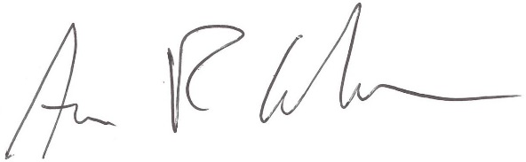
Aron R. Carlson
President, Illinois Corn Growers Association

1k2-92p3-8p0h

